Read data from file

1.Introduction

\*2 most popular class type: BufferedReader, Files

\*Different: Length can read

BufferedReader: read 1 line, character

Files: Read full text

2. BufferedReader Class

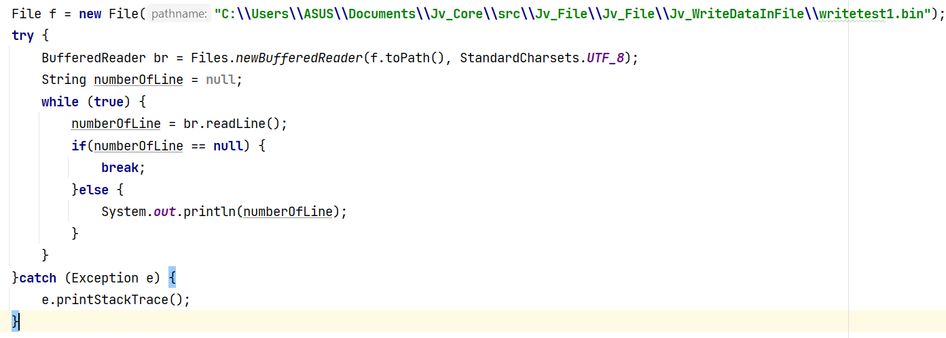

3. List class

